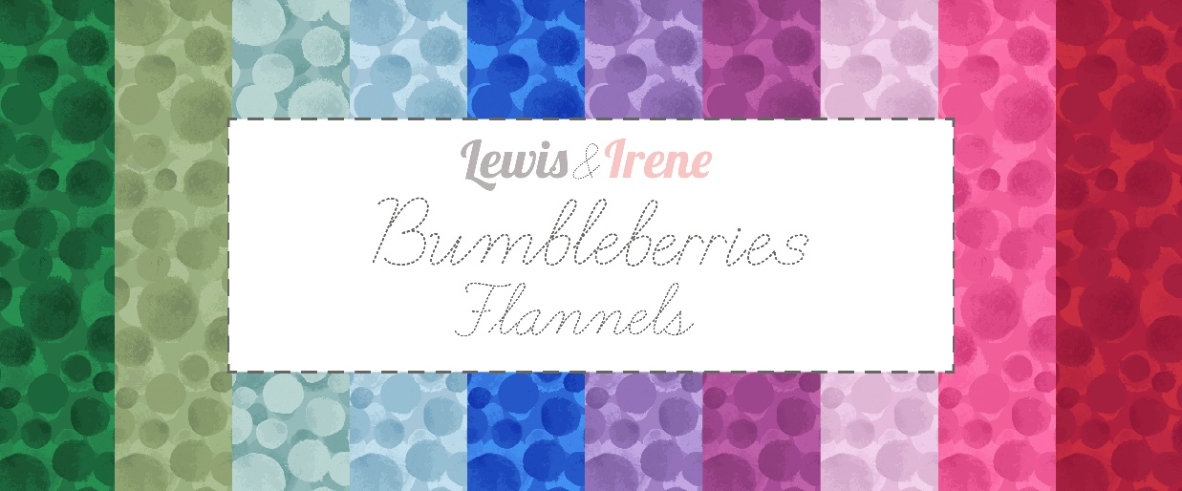
Designed and made by Sally Ablett – Throw 1
Size 54" x 54" - unfinished block size 10½" x 10½"
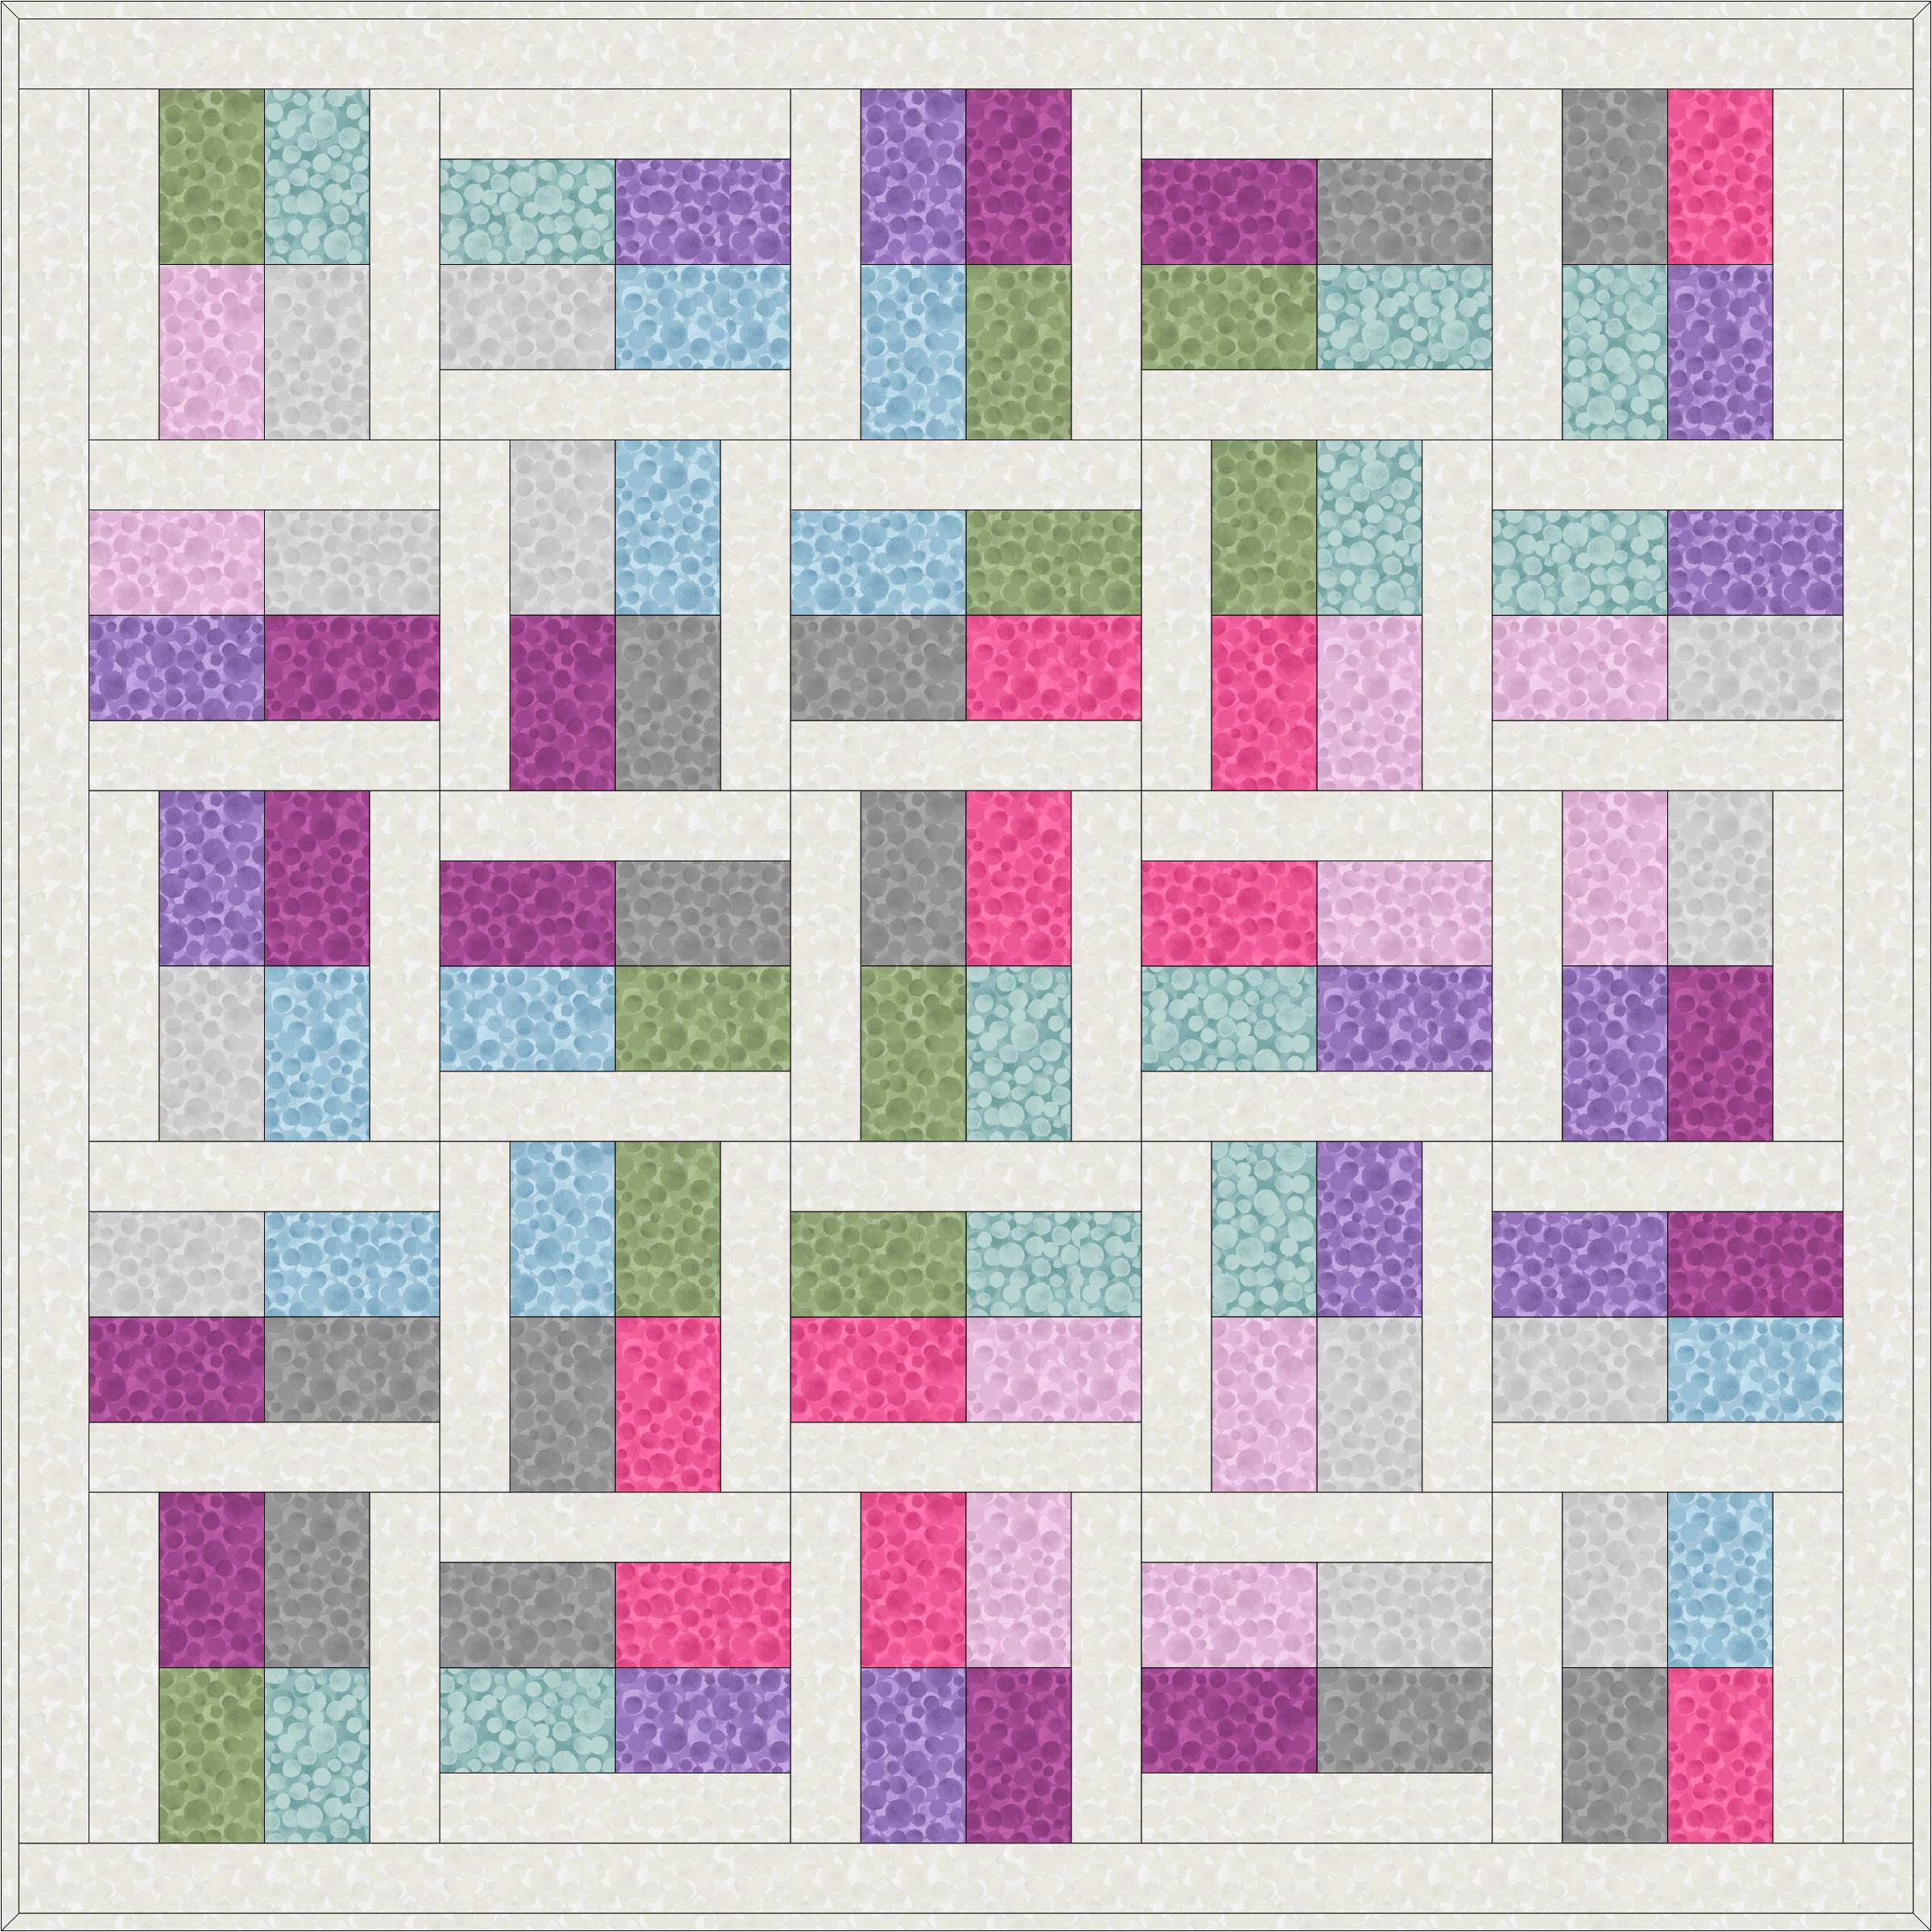
Main Diagram
Fabrics from Bumbleberries Flannels collection

Requirements
- BBF40 - Cream Bumbleberries flannel - 1¾yd - 1¾m
- BBF12 - Light grey Bumbleberries flannel - fat¼
- BBF15 - Zennor blue Bumbleberries flannel - fat¼
- BBF13 - Wiltshire green Bumbleberries flannel - fat¼
- BBF16 - Carnival pink Bumbleberries flannel - fat¼
- BBF14 - Light lavender Bumbleberries flannel - fat¼
- BBF21 - Duck egg Bumbleberries flannel - fat¼
- BBF22 - English lavender Bumbleberries flannel - fat¼
- BBF17 - Berry purple Bumbleberries flannel - fat¼
- BBF18 - Rock Bumbleberries flannel - fat¼
Wadding and backing 60" x 60"
All measurements include ¼" seam allowances; press each seam as you go.
You need to join your fabric to get the length for the border strips.
Cutting
From fabric 1 cut
2 x 2½" x 54½" top and bottom
2 x 2½" x 50½" sides
50 x 2½" x 10½"
From each of the fabrics 3, 4, 5 and 6 you need to cut
10 x 3½" x 5½
From each of the fabrics 2, 7, 8, 9 and 10 you need to cut
12 x 3½" x 5½"

Making up the blocks
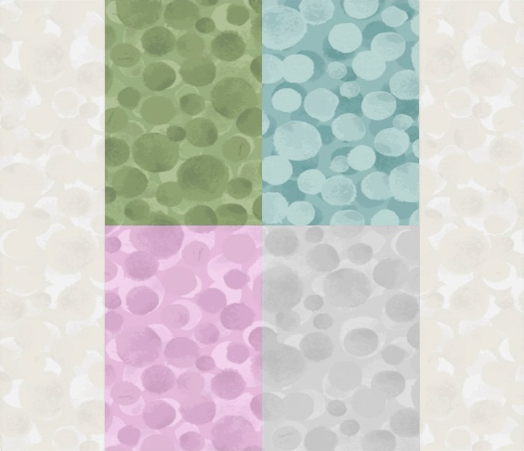 1 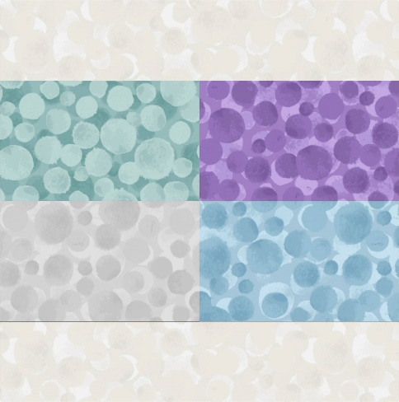 2
Look at the lay out of the fabric pieces for each block.
You will sew the centre part of the block first. Two pieces on the top row and do the same to you bottom pieces. Join the two together and then add a strip to each of the sides to complete the block. Make up all the blocks in the same way. 13 of block 1 and 12 of block 2.
Lay out all the blocks as in the main diagram. Stitch in rows together and then sew the rows together to complete throw centre.
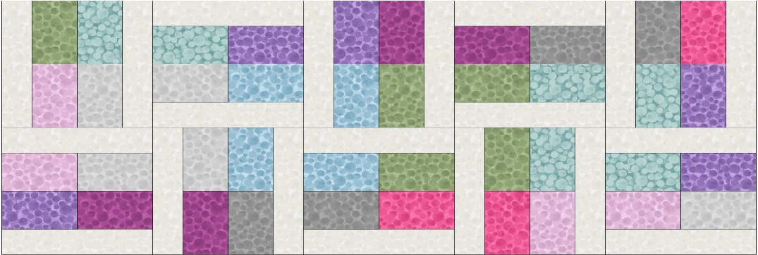 2 rows

Border
Sew the side strips to the throw, press and then the top and bottom to complete your throw.

Quilting and binding
Sandwich the quilt top, wadding and backing together.
Quilt by hand or machine a pattern to match the quilt.
Trim the backing and wadding to size of quilt.
Binding
Use your favorite method for binding the quilt.

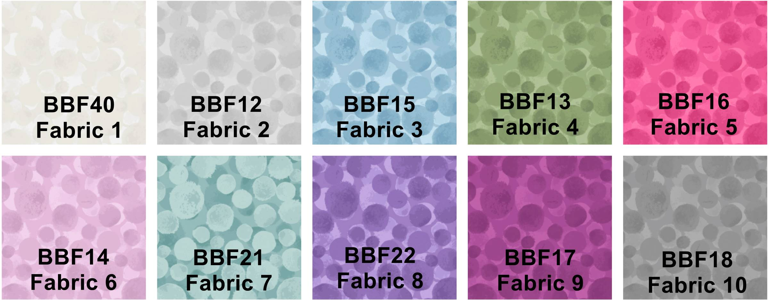
Sally Ablett © 2026

Designed and made by Sally Ablett – Throw 2
Size 54” x 54” – unfinished block size 10½” x 10½”
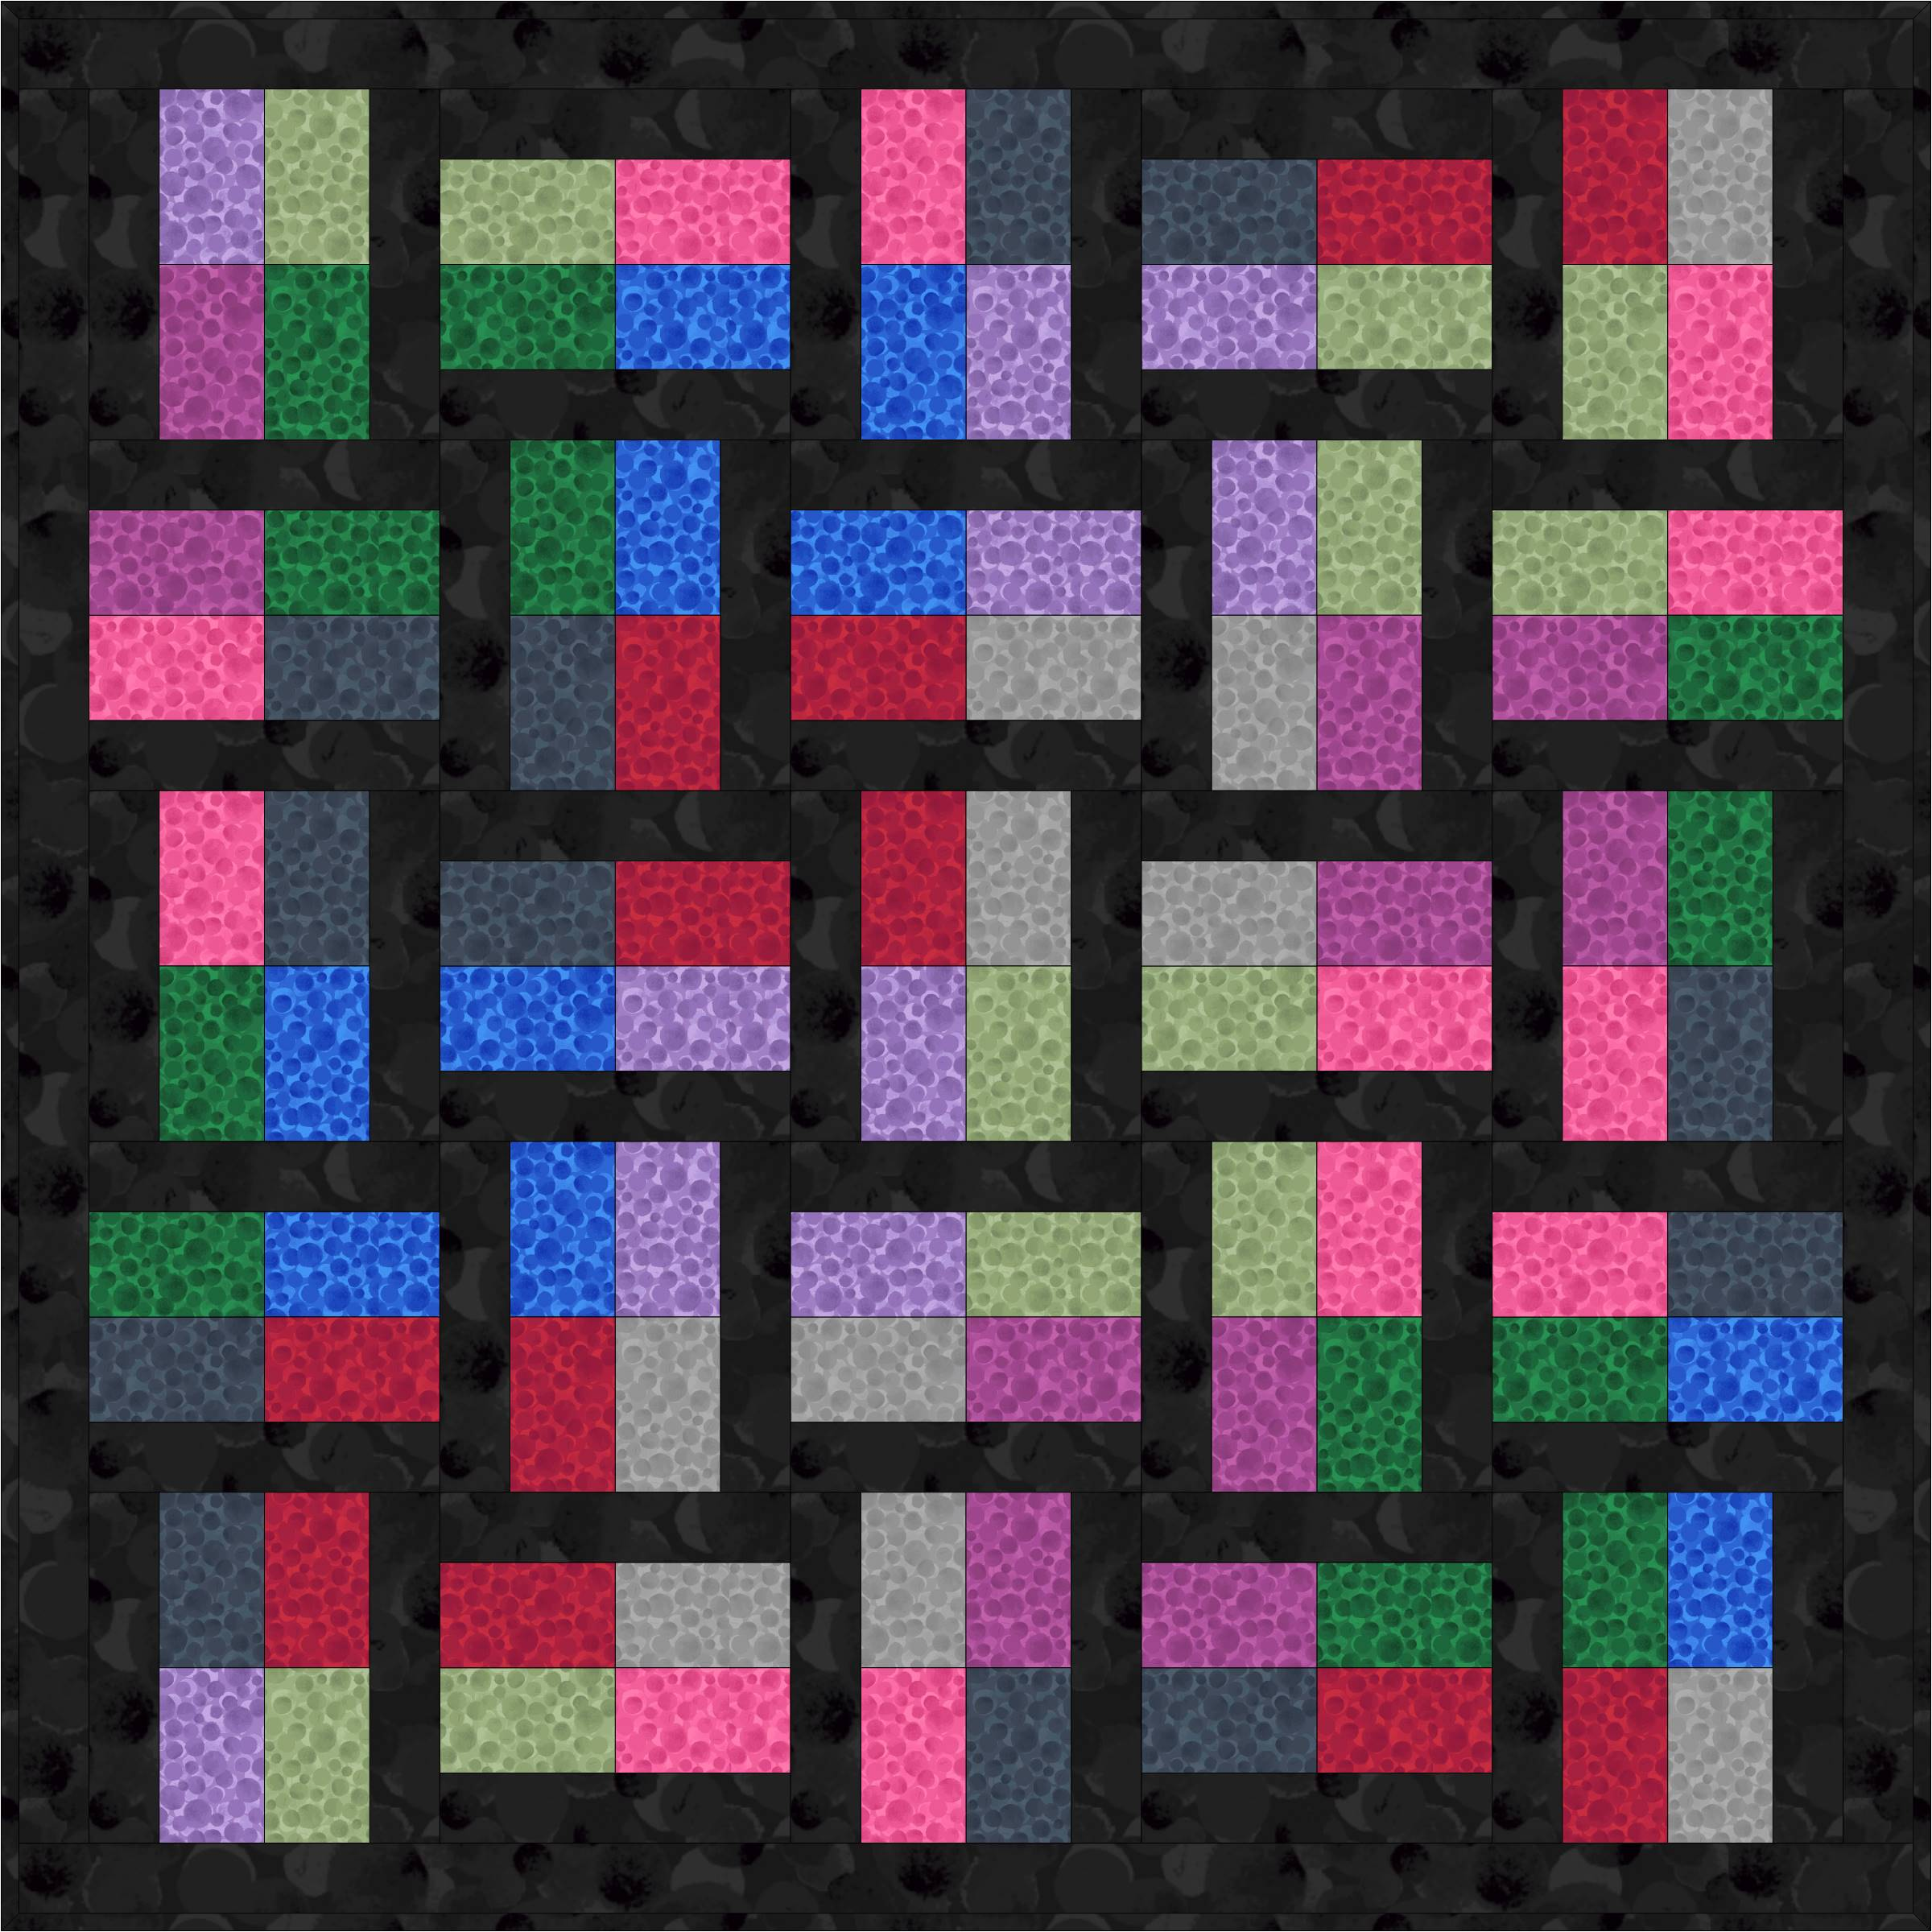
Main Diagram
Fabrics from Bumbleberries Flannels collection

Requirements
- BBF20 - Black Bumbleberries -flannel 1¾yd - 1¾m
- BBF24 - Christmas green Bumbleberries flannel - fat¼
- BBF22 - English lavender Bumbleberries flannel - fat¼
- BBF13 - Wiltshire green Bumbleberries flannel - fat¼
- BBF16 - Carnival pink Bumbleberries flannel - fat¼
- BBF19 - Indigo Bumbleberries flannel - fat¼
- BBF184 - Postbox red Bumbleberries flannel - fat¼
- BBF18 - Rock Bumbleberries flannel - fat¼
- BBF17 - Berry purple Bumbleberries flannel - fat¼
- BBF23 - Aegean blue Bumbleberries flannel - fat¼

Wadding and backing 60" x 60"
All measurements include ¼" seam allowances; press each seam as you go.
You need to join your fabric to get the length for the border strips.

Cutting
From fabric 1 cut
2 x 2½" x 54½" top and bottom
2 x 2½" x 50½" sides
50 x 2½" x 10½"
From each of the fabrics 2, 3, 4, 5 and 6 you need to cut
10 x 3½" x 5½
From each of the fabrics 7, 8, 9 and 10 you need to cut
12 x 3½" x 5½"

Making up the blocks
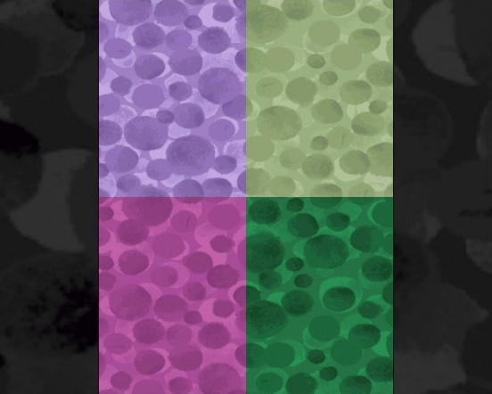 1 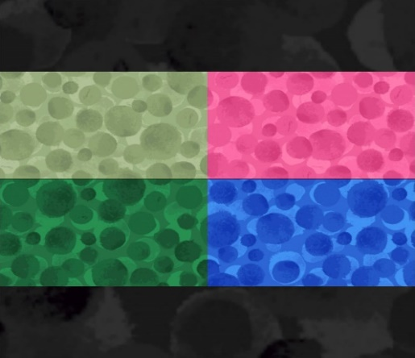 2
Look at the lay out of the fabric pieces for each block.
You will sew the centre part of the block first. Two pieces on the top row and do the same to you bottom pieces. Join the two together and then add a strip to each of the sides to complete the block. Make up all the blocks in the same way. 13 of block 1 and 12 of block 2.
Lay out all the blocks as in the main diagram. Stitch in rows together and then sew the rows together to complete throw centre.
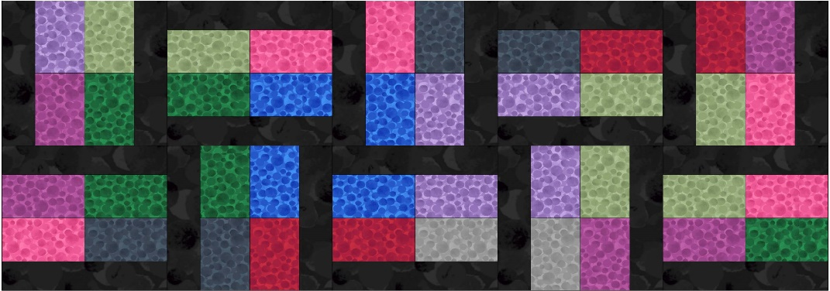

Border
Sew the side strips to the throw, press and then the top and bottom to complete your throw.

Quilting and binding
Sandwich the quilt top, wadding and backing together.
Quilt by hand or machine a pattern to match the quilt.
Trim the backing and wadding to size of quilt.

Binding
Use your favorite method from fabric 1 for binding the quilt.

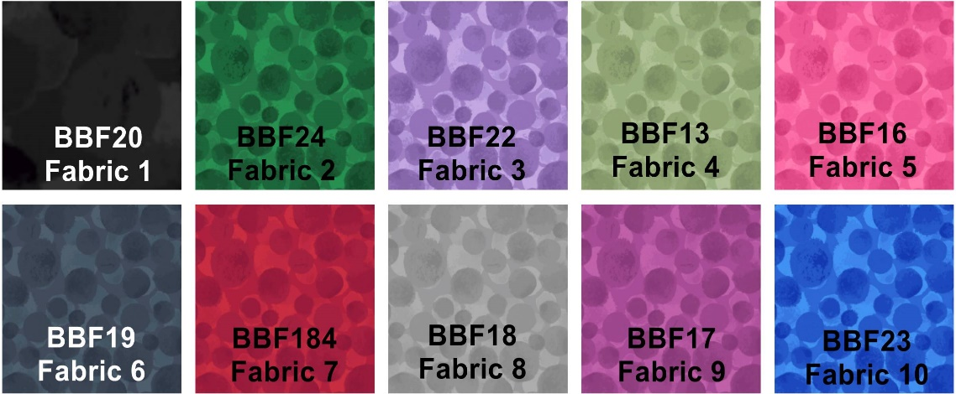
Sally Ablett © 2026

