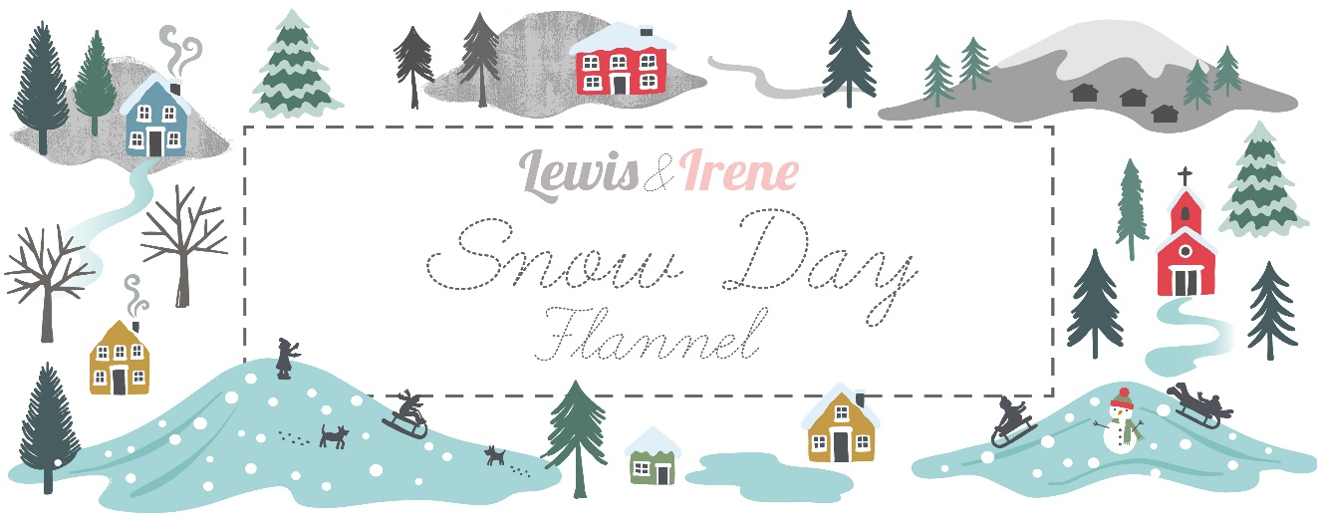
Designed and made by Sally Ablett - Throw 1
Size of quilt 54" x 57" - unfinished strips size 3½" x 8½" and 3½" x 4½"
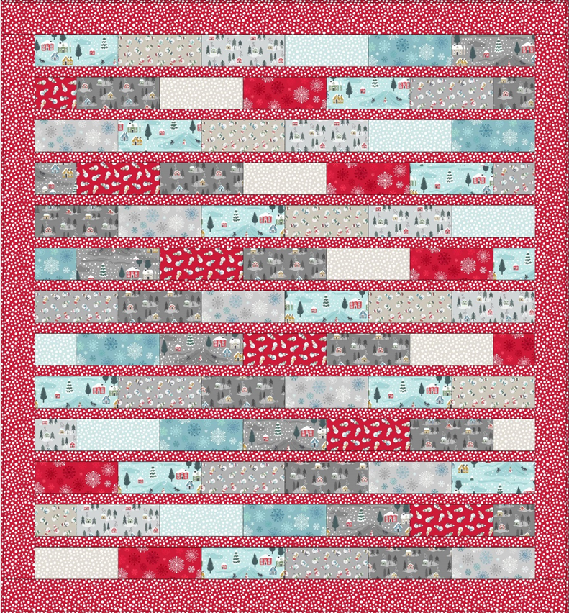
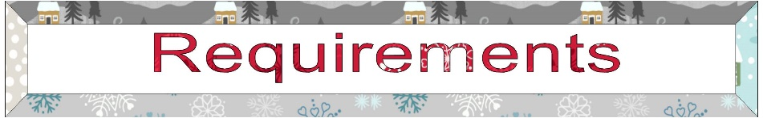
Fabrics from the Snow Day flannel collection.

- F34.1 - Snow Day on cream - fat¼
- F34.2 - Snow Day on icy blue - fat¼
- F34.3 - Snow Day on grey - fat¼
- F35.1 - Scattered snowmen on dark cream - fat¼
- F35.2 - Scattered snowmen on grey - fat¼
- F35.3 - Scattered snowmen on red - fat¼
- F36.1 - Snow Day houses on silver - fat¼
- F36.2 - Snow Day houses on icy blue - fat¼
- F36.3 - Snow Day houses on grey - fat¼
- F38.1 - Snow fall on icy blue - fat¼
- F38.2 - Snow fall on dark cream - fat¼
- F38.3 - Snow fall on red 1 5/8yds
- F72.1 - Snowflakes on grey - fat¼
- F72.2 - Snowflakes on ice blue - fat¼
- F72.3 - Snowflakes on red - fat¼
Wadding and backing 58" x 61"
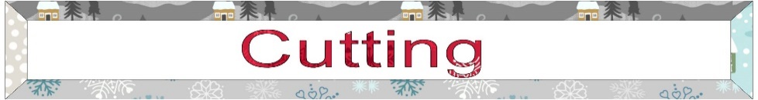
All measurements include ¼" seam allowances; press each seam as you go.
You need to join your fabric to get the length for the sashing and border strips.
From each of the fabrics 2 and 13 you need to cut
6 x 3½" x 8½"
From each of the fabrics 1, 3,4,5,6,7,8,9,10,11,14 and 15 you need to cut
5 x 3½" x 8½"
1 x 3½x 4½"
From fabric 12 cut (Cut fabric lengthwise to get the measurement needed)
12 x 1½" x 48½"
2 x 3½" x 51½" sides
2 x 3½" x 54½" top and bottom
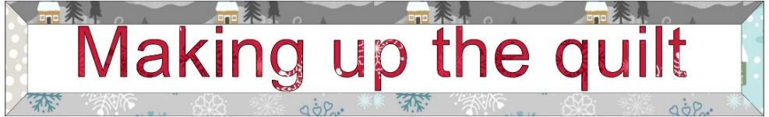
Lay out the fabrics for the quilt as in the main diagram with the sashing in between.
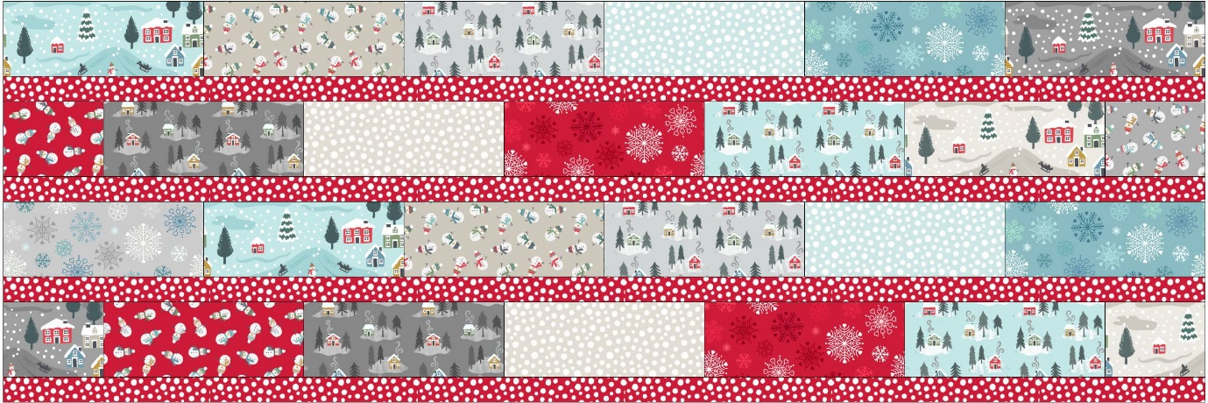
This is the top of the quilt. Sew the strips together to complete the row.
Stitch all the strips together and then sew each row together to complete the quilt center.
Border : sew the sides to the quilt, press back then the top and bottom.
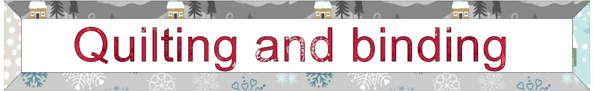
Sandwich quilt top, wadding and backing together. Quilt by hand or machine as desired or maybe you could do some dogs and cats in the quilting.
Trim backing and wadding to size of quilt.
Binding
Use your favourite method from fabric 12 to bind the quilt.

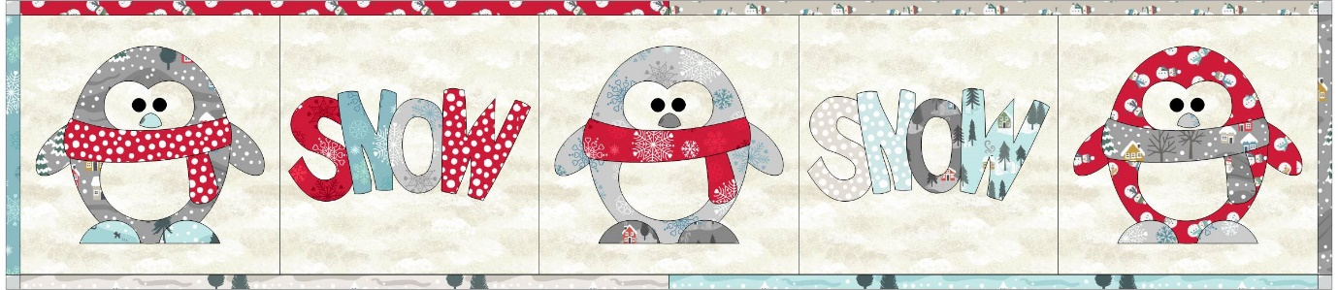
Sally Ablett 2023 ©
Designed and made by Sally Ablett Throw 2
Size of quilt 54" x 57" - unfinished strips size 3½" x 8½" and 3½" x 4½"
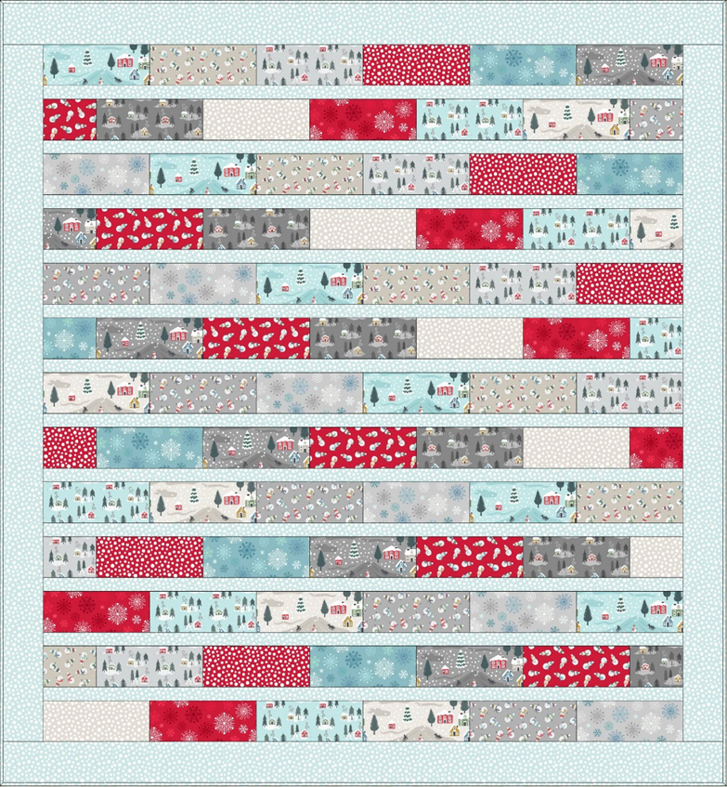
Fabrics from the Snow Day flannel collection.

- F34.1 - Snow Day on cream - fat¼
- F34.2 - Snow Day on icy blue - fat¼
- F34.3 - Snow Day on grey - fat¼
- F35.1 - Scattered snowmen on dark cream - fat¼
- F35.2 - Scattered snowmen on grey - fat¼
- F35.3 - Scattered snowmen on red - fat¼
- F36.1 - Snow Day houses on silver - fat¼
- F36.2 - Snow Day houses on icy blue - fat¼
- F36.3 - Snow Day houses on grey - fat¼
- F38.1 - Snow fall on icy blue 1 5/8 yds
- F38.2 - Snow fall on dark cream - fat¼
- F38.3 - Snow fall on red - fat¼
- F72.1 - Snowflakes on grey - fat¼
- F72.2 - Snowflakes on ice blue - fat¼
- F72.3 - Snowflakes on red - fat¼
Wadding and backing 58" x 61"
All measurements include ¼" seam allowances; press each seam as you go.
You need to join your fabric to get the length for the sashing and border strips.
From each of the fabrics 2 and 13 you need to cut
6 x 3½" x 8½"
From each of the fabrics 1, 3,4,5,6,7,8,9,11,12,14 and 15 you need to cut
5 x 3½" x 8½"
1 x 3½x 4½"
From fabric 10 cut (Cut fabric lengthwise to get the measurement needed)
12 x 1½" x 48½"
2 x 3½" x 51½" sides
2 x 3½" x 54½" top and bottom
Lay out the fabrics for the quilt as in the main diagram with the sashing in between.
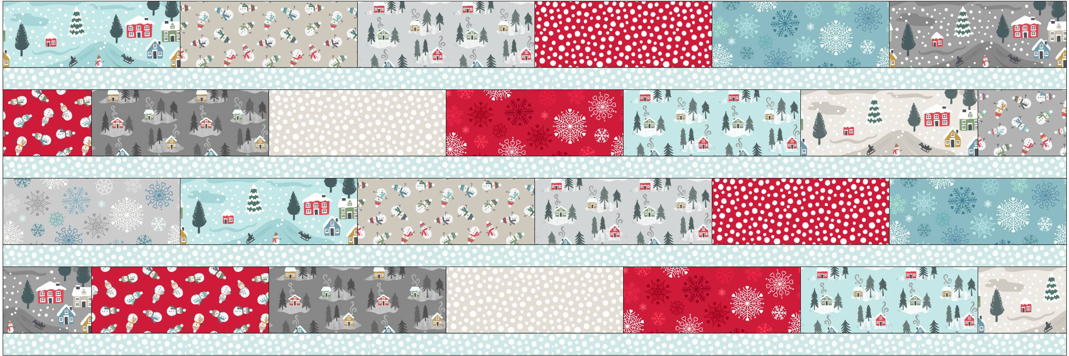
This is the top of the quilt. Sew the strips together to complete the row.
Stitch all the strips together and then sew each row together to complete the quilt center.
Border : sew the sides to the quilt, press back then the top and bottom.
Sandwich quilt top, wadding and backing together. Quilt by hand or machine as desired or maybe you could do some dogs and cats in the quilting.
Trim backing and wadding to size of quilt.
Binding
Use your favourite method from fabric 10 to bind the quilt.

Sally Ablett 2023 ©
Designed and made by Sally Ablett Throw 3
Size of quilt 54" x 57" - unfinished strips size 3½" x 8½" and 3½" x 4½"
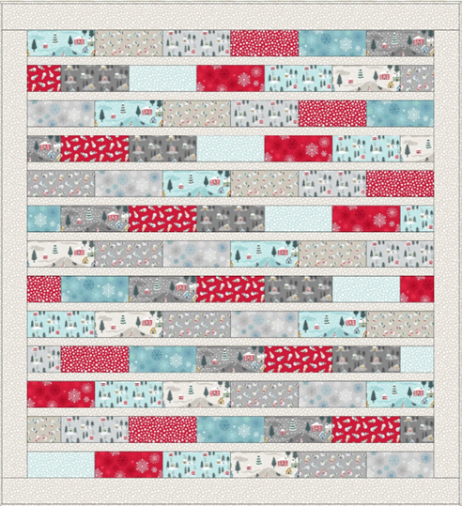
Fabrics from the Snow Day flannel collection.
- F34.1 - Snow Day on cream - fat¼
- F34.2 - Snow Day on icy blue - fat¼
- F34.3 - Snow Day on grey - fat¼
- F35.1 - Scattered snowmen on dark cream - fat¼
- F35.2 - Scattered snowmen on grey - fat¼
- F35.3 - Scattered snowmen on red - fat¼
- F36.1 - Snow Day houses on silver - fat¼
- F36.2 - Snow Day houses on icy blue - fat¼
- F36.3 - Snow Day houses on grey - fat¼
- F38.1 - Snow fall on icy blue - fat¼
- F38.2 - Snow fall on dark cream – 1 5/8 yds
- F38.3 - Snow fall on red - fat¼
- F72.1 - Snowflakes on grey - fat¼
- F72.2 - Snowflakes on ice blue - fat¼
- F72.3 - Snowflakes on red - fat¼
Wadding and backing 58" x 61"
All measurements include ¼" seam allowances; press each seam as you go.
You need to join your fabric to get the length for the sashing and border strips.
From each of the fabrics 2 and 13 you need to cut
6 x 3½" x 8½"
From each of the fabrics 1, 3,4,5,6,7,8,9,10,12,14 and 15 you need to cut
5 x 3½" x 8½"
1 x 3½x 4½"
From fabric 11 cut (Cut fabric lengthwise to get the measurement needed)
12 x 1½" x 48½"
2 x 3½" x 51½" sides
2 x 3½" x 54½" top and bottom
Lay out the fabrics for the quilt as in the main diagram with the sashing in between.
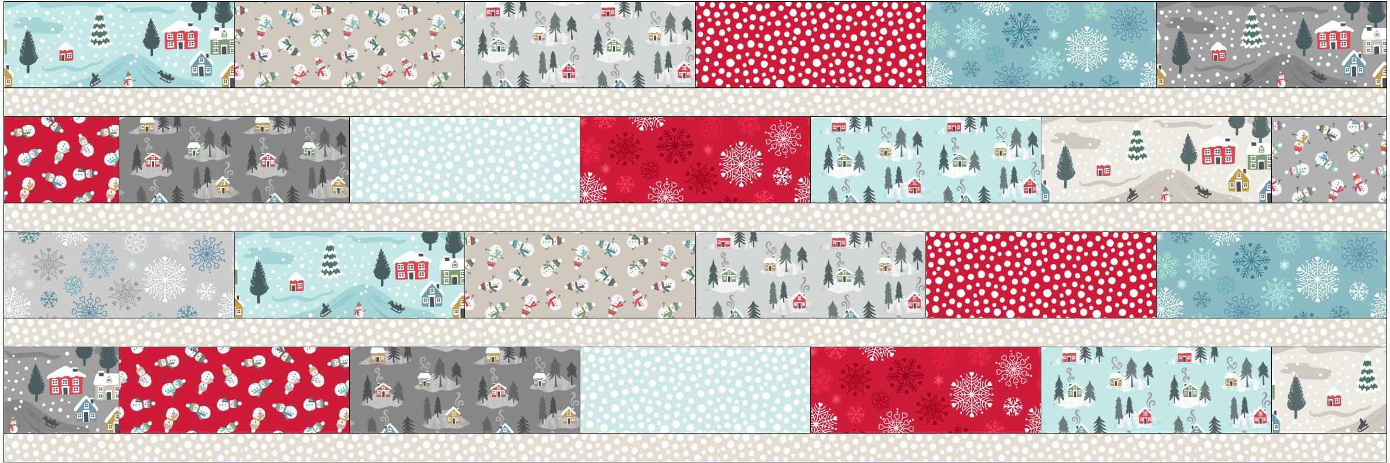
This is the top of the quilt. Sew the strips together to complete the row.
Stitch all the strips together and then sew each row together to complete the quilt center.
Border : sew the sides to the quilt, press back then the top and bottom.
Sandwich quilt top, wadding and backing together. Quilt by hand or machine as desired or maybe you could do some dogs and cats in the quilting.
Trim backing and wadding to size of quilt.
Binding
Use your favourite method from fabric 11 to bind the quilt.

Sally Ablett 2023 ©

